|  |  |  |
| --- | --- | --- |
| **LAB101 Assignment** | **Type:** | **Short Assignment** |
| **Code:** | **C.S.P0031** |
| **LOC:** | **40** |
| **Slot(s):** | **1** |

**Title**

Convert decimal to binary.

**Background**

N/A

**Program Specifications**

Design a program that allows users to input a positive integer and output the corresponding binary form.

The program should be repetitive until users close the program.

***Function details:***

1. Function 1: Display a screen to prompt users to input a positive decimal number.

* Users run the program, display a screen to ask users to enter a positive decimal number.
* Users input a positive decimal number. Then, perform Function 2.

1. Function 2: Convert decimal to binary.

* The program converts the inputted decimal to corresponding binary, and returns an array containing those converted bits from left to right.
* Perform Function 3.

1. Function 3: Output bits stored in the array to the screen.

***Expectation of User interface:***

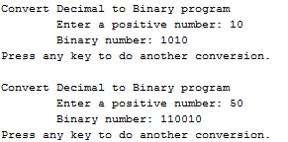

**Guidelines**

**Example: convert 1110 to binary from**

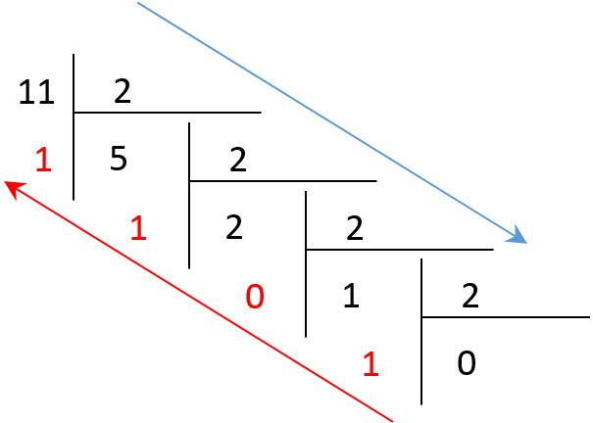

In the above division, we want to have the binary form of the decimal 11. We perform as follows:

11 divided by 2, we have remainder of 1, quotient of 5

Quotient 5 divided by 2, we have remainder of 1, quotient of 2

Repeat the process until the quotient is 0.

Then combine from bottom-up all the remainders and we have the binary form of 11

And we have the corresponding binary form of 11: 1011

* *Students should use the provided dump_line() function to clear the buffer after invoking the scanf() function (call: dump_line(stdin)).*